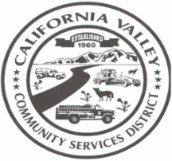CALIFORNIA VALLEY COMMUNITY SERVICES DISTRICT

**HCR 69 BOX 3094 CALIFORNIA VALLEY, CA 93453**

**13080 SODA LAKE RD, CALIFORNIA VALLEY, CA 93453**

**PH: (805) 475-2211 FAX: (805) 475-2758**

[Cvcsd3094@gmail.com](mailto:Cvcsd3094@gmail.com) **californiavalley.org**

**AGENDA**

For a Policy Committee Meeting of the California Valley Community Services District

13080 Soda Lake Rd, California Valley, CA 93543

To be Held on Thursday August 12, 2021 @ 12:00 PM

**DIRECTOR STAFF**

Piper Wilson- Chair Karina Sanchez, General Manager

Ruth Legaspi -Co/ Chair

1.) CALL TO ORDER

2.) ROLL CALL

3.) DISCUSSION AND MOTION ON AUDITOR’S ANNUAL POLICY RECOMMENDATIONS

4.) DISCUSSION AND MOTION ON REVISING CHAPTER 5000- FACILITIES DEVELOPMENT, OF THE POLICY BOOK

Adjourned:

Next Meeting: TBA

Posted: Thursday August 5, 2021

American with Disabilities Act

If you need a disability-related modification or accommodation to participate in this meeting, please contact (General Manager) at (805)-475-2211. Requests must be submitted one full business day before the meeting.