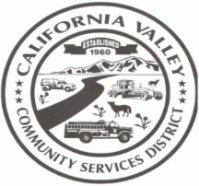CALIFORNIA VALLEY COMMUNITY SERVICES DISTRICT

**HCR 69 BOX 3094 CALIFORNIA VALLEY, CA 93453**

**13080 SODA LAKE RD, CALIFORNIA VALLEY, CA 93453**

**PH: (805) 475-2211 FAX: (805) 475-2758**

[Cvcsd3094@gmail.com](mailto:Cvcsd3094@gmail.com) **californiavalley.org**

**MINUTES**

Of a Finance Committee Meeting of the California Valley Community Services District

13080 Soda Lake Rd, California Valley, CA 93453

Held on Thursday August 12, 2021 @ 10.00 AM

**DIRECTOR** **STAFF**

Ruth Legaspi- Chair Karina Sanchez- General Manager

Nancy Glowski- Co Chair

1.) CALL TO ORDER-10:21 AM

2.) ROLL CALL- Director Legaspi- here, Director Glowski- absent, GM Sanchez- here.

3.) DISCUSSION ON CHECKS AND BALANCES: APRIL 2021-JULY 2021- The Finance committee went through April, May, June, July 2021 bank statements and filled out monthly finance reports.

Adjourned: 10:41 AM

Next Meeting: TBA

Posted: Thursday August 12, 2021

American with Disabilities Act

If you need a disability-related modification or accommodation to participate in this meeting, please contact (General Manager) at (805)-475-2211. Requests must be submitted one full business day before the meeting.