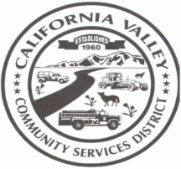CALIFORNIA VALLEY COMMUNITY SERVICES DISTRICT

**HCR 69 BOX 3094 CALIFORNIA VALLEY, CA 93453**

**13080 SODA LAKE RD, CALIFORNIA VALLEY, CA 93453**

**PH: (805) 475-2211 FAX: (805) 475-2758**

[Cvcsd3094@gmail.com](mailto:Cvcsd3094@gmail.com) **californiavalley.org**

**AGENDA**

For a SWCD Committee Meeting of the California Valley Community Services District

13080 Soda Lake Rd, California Valley, CA 93453

To Be Held on Nov 14, 2022, @ 12:30 PM

**DIRECTOR** **STAFF**

Ruth Legaspi- Chair Karina Sanchez, General Manager

Piper Wilson- Co-Chair

1.) CALL TO ORDER

2.) ROLL CALL

3.) DISCUSSION ON PROPOSITION 218. FINALIZING DRAFT NOTICE OF PUBLIC HEARING, TO BE ABLE TO CONTINUE TO PROVIDE SOLID WASTE AND RECYCLING SERVICES.

Adjourned:

Next Meeting: TBA

Posted: Monday November 7, 2022

Americans with Disabilities Act

If you need a disability-related modification or accommodation to participate in this meeting, please contact (General Manager) at (805)-475-2211. Requests must be submitted one full business day before the meeting.